**Prof.V.B.Shah Institute of Management &R.V.Patel College of Commerce (Eng. Med.) &V.L.Shah College of Commerce (Guj.Med.) &**

**Sutex Bank College of Computer Applications& Science, Amroli**

**(Accredited ‘B’ (CGPA 2.55) by NAAC Dec.-2009)**

# VEER NARMAD SOUTH GUJARAT UNIVERSITY, SURAT



**SEMINAR REPORT**

**ON**

**CLOUD COMPUTING - AWS**

**AS A PARTIAL REQUIREMENT FOR THE DEGREE**

**OF**

**BACHELOR OF COMPUTER APPLICATION**

**(B.C.A.)**

SUBMITTED BY: GUIDED BY:

MUKUND N. JAGANI Asst. Prof. Nensi Modi

Roll No.: 662

TYBCA Div. – 6

# Index

|  |  |  |
| --- | --- | --- |
| No. | Name | Page no. |
| 1 | **Introduction** | **1** |
| 2 | **Architecture of cloud computing** | **4** |
| 3 | **Characteristic Of Cloud Computing** | **5** |
| 4 | **Cloud service model** | **7** |
| 5 | **Is Cloud Computing reducing e-waste?** | **13** |
| 6 | **Advantages** | **14** |
| 7 | **Disadvantages** | **16** |
| 8 | **Amazon Web Services** | **17** |
| 9 | **Competitors of AWS** | **18** |
| 10 | **Customer of AWS** | **19** |
| 11 | **Conclusion** | **20** |

1. Introduction

Computing and Software resources that are delivered on demand, as services ((2013, January) A Walk in the clouds. Cloud Computing, CDW-G Reference Guide.,3-5.)

The Cloud is actually a bunch of computer server that store and transmit data. These servers are very large and can hold massive amount of data. The servers can be housed anywhere in the world. The user accesses the data by log-in form anywhere.

Cloud computing is the delivery of different services through the Internet. These resources include tools and applications like data storage, servers, databases, networking, and software.

Rather than keeping files on a proprietary hard drive or local storage device, [cloud-based storage](https://www.investopedia.com/terms/c/cloud-storage.asp) makes it possible to save them to a remote database. As long as an electronic device has access to the web, it has access to the data and the software programs to run it.

* Meaning of cloud computing

**C**ommon implies multi-tenancy, not single or isolated tenancy

**L**ocation-independent

**O**nline

**U**tility implies pay-for-use pricing

**D**emand implies infinite, immediate, invisible scalability

Types of Cloud Services

Regardless of the kind of service, cloud computing services provide users with a series of functions including:

* Email
* Storage, backup, and data retrieval
* Creating and testing apps
* Analyzing data
* Audio and video streaming
* Delivering software on demand

Cloud computing is still a fairly new service but is being used by a number of different organizations from big corporations to small businesses, nonprofits to government agencies, and even individual consumers.

WHY CHOOSE CLOUD COMPUTING?

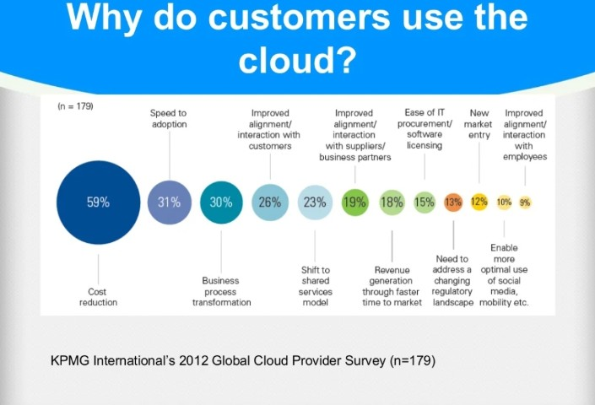

1. Architecture of cloud computing

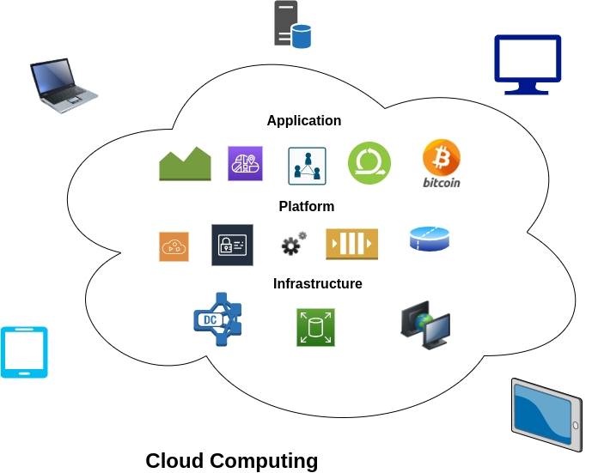

the systems architecture of the software systems involved in the delivery of cloud computing, typically involves multiple cloud components communicating with each other over a loose coupling mechanism such as a messaging queue. Elastic provision implies intelligence in the use of tight or loose coupling as applied to mechanisms such as these and others.

1. Characteristic of cloud computing

* On-Demand Self-Service
* Flexible Pricing – Pay Per Use
* Rapid Elasticity
* Resource Pooling
* Ubiquitous Network Access
* The National Institute of Standards and Technology's definition of cloud computing identifies "five essential characteristics":
* On-demand self-service. A consumer can unilaterally provision computing capabilities, such as server time and network storage, as needed automatically without requiring human interaction with each service provider.
* Broad network access (Ubiquitous Network Access). Capabilities are available over the network and accessed through standard mechanisms that promote use by heterogeneous thin or thick client platforms (e.g., mobile phones, tablets, laptops, and workstations).
* Resource pooling. The provider's computing resources are pooled to serve multiple consumers using a multi-tenant model, with different physical and virtual resources dynamically assigned and reassigned according to consumer demand.
* Rapid elasticity. Capabilities can be elastically provisioned and released, in some cases automatically, to scale rapidly outward and inward commensurate with demand. To the consumer, the capabilities available for provisioning often appear unlimited and can be appropriated in any quantity at any time.
* Flexible Pricing – Pay Per Use- Cloud systems automatically control and optimize resource use by leveraging a metering capability at some level of abstraction appropriate to the type of service (e.g., storage, processing, bandwidth, and active user accounts). Resource usage can be monitored, controlled, and reported, providing transparency for both the provider and consumer of the utilized service.

1. Cloud service model

* Software as a Service (SaaS)
* Platform as a Service (PaaS)
* Infrastructure as a Service (IaaS)

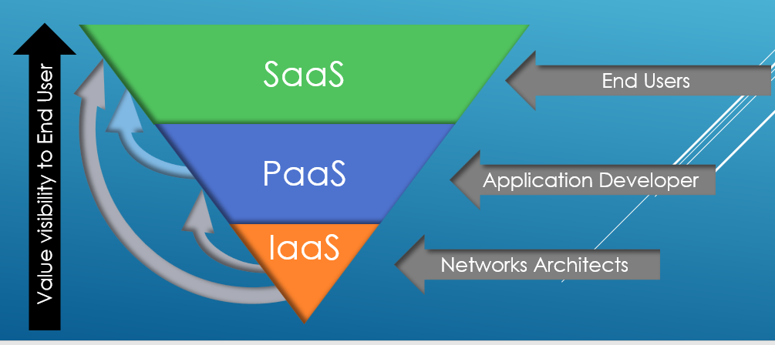

* Software as a Service (SaaS)
  + - SaaS is Software delivery methodology that provide licensed multi-tenant access to software and its function remotely as a web-based services.
    - End Users
    - Google, salesforce, IBM, Netflix, HubSpot, Office 365
* Software as a service is a method for delivering software applications over the Internet, on demand and typically on a subscription basis. With SaaS, cloud providers host and manage the software application and underlying infrastructure and handle any maintenance, like software upgrades and security patching. Users connect to the application over the Internet, usually with a web browser on their phone, tablet or PC.
* Platform as a Service (PaaS)
  + - PaaS provides all of the facilities required to support the complete life cycle of building and delivering web application and services entirely from the Internet.
    - Application Developers
    - Rollbase, Microsoft Azure, OpenShift
* Platform as a service refers to cloud computing services that supply an on-demand environment for developing, testing, delivering and managing software applications. PaaS is designed to make it easier for developers to quickly create web or mobile apps, without worrying about setting up or managing the underlying infrastructure of servers, storage, network and databases needed for development.
* Infrastructure as a Service (IaaS)
  + - IaaS is the delivery of technology infrastructure on demand scalable service.
    - Network Architects
    - IT administrators
    - Vmware, AWS (Amazon Web Services), rackspace, Alibaba cloud
* The most basic category of cloud computing services. With IaaS, you rent IT infrastructure—servers and virtual machines (VMs), storage, networks, operating systems—from a cloud provider on a pay-as-you-go basis.

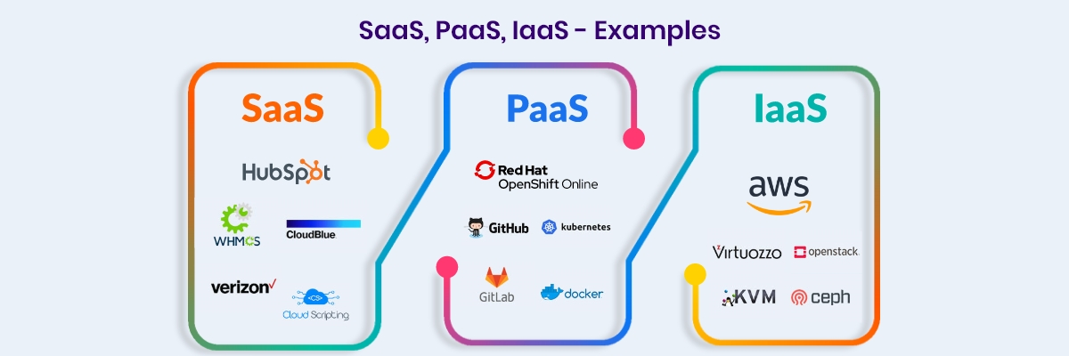

* 1. Cloud Deployment Model
* Private Cloud
* Public Cloud
* Hybrid Cloud
* Private cloud
* Private cloud is cloud infrastructure operated solely for a single organization, whether managed internally or externally. These services use storage capacity and processor power that is not owned by the organization or business. Less cost-efficient
* Amazon, Google, Microsoft
* Public clouds are owned and operated by a third-party [cloud service providers](https://azure.microsoft.com/en-in/overview/choosing-a-cloud-service-provider/), which deliver their computing resources like servers and storage over the Internet. Microsoft Azure is an example of a public cloud. With a public cloud, all hardware, software and other supporting infrastructure is owned and managed by the cloud provider. You access these services and manage your account using a web browser.
* Public cloud
* Public cloud is a style of computing where scalable and elastic IT-enabled capabilities are provided as a service to external customer using Internet technologies. i.e., public cloud computing uses cloud computing technologies to support customer that are external to the provider’s organization.
* HP data center, IBM, SUN, Oracle
* A private cloud refers to cloud computing resources used exclusively by a single business or organization. A private cloud can be physically located on the company’s on-site datacenter. Some companies also pay third-party service providers to host their private cloud. A private cloud is one in which the services and infrastructure are maintained on a private network.
* Hybrid cloud
* Hybrid cloud is a composition of two or more clouds (private, community or public) that remain distinct entities but are bound together, offering the benefits of multiple deployment models. Hybrid cloud can also mean the ability to connect collection, managed and dedication services with cloud resources.
* Hybrid clouds combine public and private clouds, bound together by technology that allows data and applications to be shared between them. By allowing data and applications to move between private and public clouds, a hybrid cloud gives your business greater flexibility, more deployment options and helps optimize your existing infrastructure, security and compliance.

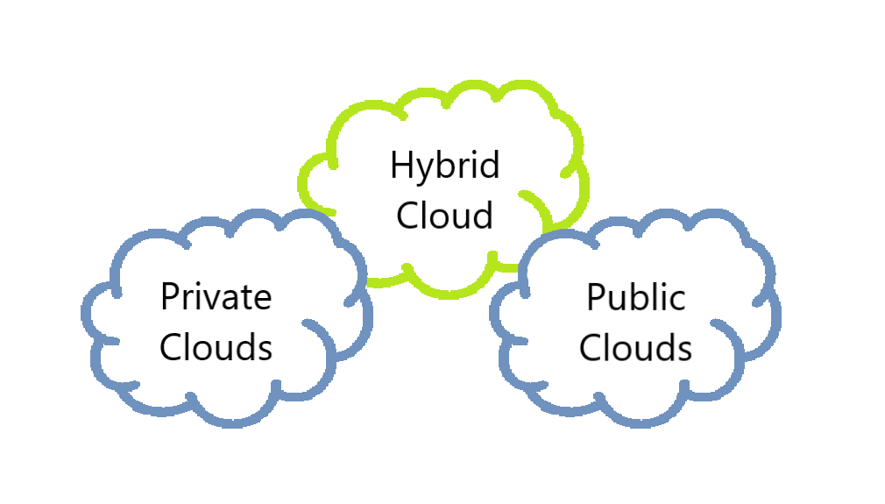

Private cloud + Public cloud = Hybrid cloud

CLOUD DEPLOYMENT MODEL

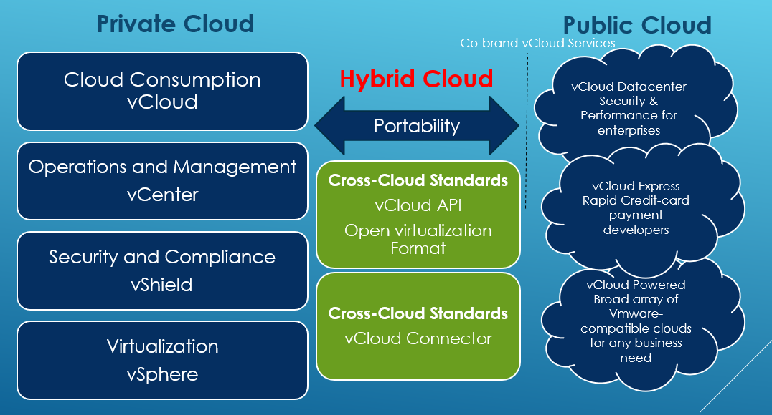

1. Is Cloud Computing reducing e-waste?

* Green IT Cloud Computing
* Cloud Computing is Eco-Friendly
* We can reduce E-waste by using Cloud Computing i.e. By Infrastructure as a Service (IaaS)
* Cloud Computing Helps to Accelerate Green IT
* Can Reduce Global Warming too…...
* Cloud computing can help companies reduce their e-waste in several ways. First, companies no longer have to purchase, repair, or replace hardware for an on-site IT infrastructure when they sign up for cloud-based solutions.

1. Advantages

* Environment Friendly
* Infinite Storage
* Cost Proficient
* More Secure
* More Flexible
* Software Integration
* Backup& Recovery
* Rapid Development
* Document Control
* Streamline
* Workflow

Top Advantages of Cloud Computing

Cloud computing is a big shift from the traditional way businesses think about IT resources. Here are seven common reasons organizations are turning to cloud computing services:

COST: -

Cloud computing eliminates the capital expense of buying hardware and software and setting up and running on-site datacenters—the racks of servers, the round-the-clock electricity for power and cooling, the IT experts for managing the infrastructure. It adds up fast.

SPEED: -

Most cloud computing services are provided self service and on demand, so even vast amounts of computing resources can be provisioned in minutes, typically with just a few mouse clicks, giving businesses a lot of flexibility and taking the pressure off capacity planning.

GLOBLE SCALE: -

The benefits of cloud computing services include the ability to scale elastically. In cloud speak, that means delivering the right amount of IT resources—for example, more or less computing power, storage, bandwidth—right when it is needed and from the right geographic location.

PRODUCTIVITY: -

On-site datacenters typically require a lot of “racking and stacking”—hardware setup, software patching, and other time-consuming IT management chores. Cloud computing removes the need for many of these tasks, so IT teams can spend time on achieving more important business goals.

PERFORMANCE: -

The biggest cloud computing services run on a worldwide network of secure datacenters, which are regularly upgraded to the latest generation of fast and efficient computing hardware. This offers several benefits over a single corporate datacenter, including reduced network latency for applications and greater economies of scale.

RELIABLITY: -

Cloud computing makes data backup, disaster recovery and business continuity easier and less expensive because data can be mirrored at multiple redundant sites on the cloud provider’s network.

SECURITY: -

Many cloud providers offer a broad set of policies, technologies and controls that strengthen your security posture overall, helping protect your data, apps and infrastructure from potential threats.

1. Disadvantages

* Requires a constant internet connection
* Limited Features
* May be slow
* Prioritize And Summarized
* Doesn’t work well in low-speed connection

With all of the speed, efficiencies, and innovations that come with cloud computing, there are, naturally, risks.

Security has always been a big concern with the cloud especially when it comes to sensitive medical records and financial information. While regulations force cloud computing services to shore up their security and compliance measures, it remains an ongoing issue. Encryption protects vital information, but if that encryption key is lost, the data disappears.

Servers maintained by cloud computing companies may fall victim to natural disasters, internal bugs, and power outages, too. The geographical reach of cloud computing cuts both ways: A blackout in California could paralyze users in New York, and a firm in Texas could lose its data if something causes its Maine-based provider to crash.

As with any technology, there is a learning curve for both employees and managers. But with many individuals accessing and manipulating information through a single portal, inadvertent mistakes can transfer across an entire system.

1. Amazon Web services

26 Regions

84 Availability Zones

52 Edge Locations

YOU CHOOSE WHERE YOUR APPS AND DATA GO!

* AWS (Amazon Web Services) is a subsidiary of Amazon.com
* It provides on-demand cloud computing platforms.
* The AWS technology is implemented at server farms throughout the world, and maintained by the Amazon subsidiary.
* A data center is also called server farm.
* It is a facility used to house computer systems and associated components, such as telecommunication and storage systems.
* AWS are operated from 16 geographical regions across the world and operated using zone and edge location.
* AWS is the world’s most comprehensive and broadly adopted cloud platform, offering 200 fully featured services from data center globally
* NASA JPL uses AWS for Image Processing and streaming of the Mars Landing
* Obama for the America used AWS to run Mission Critical Applications
* Apple spends more than $30 million on Amazon’s AWS every month (Biggest AWS Customer)
* AWS serves over a million active customer in more than 240 countries and territories

1. Competitors of AWS

* Google Cloud Platform
* Microsoft Azure
* IBM Cloud
* Oracle Cloud
* Vmware Cloud
* Dell Technologies Cloud
* Alibaba Cloud

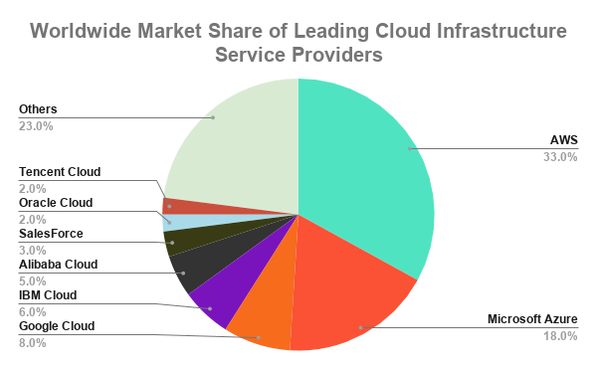

10.Customer of AWS

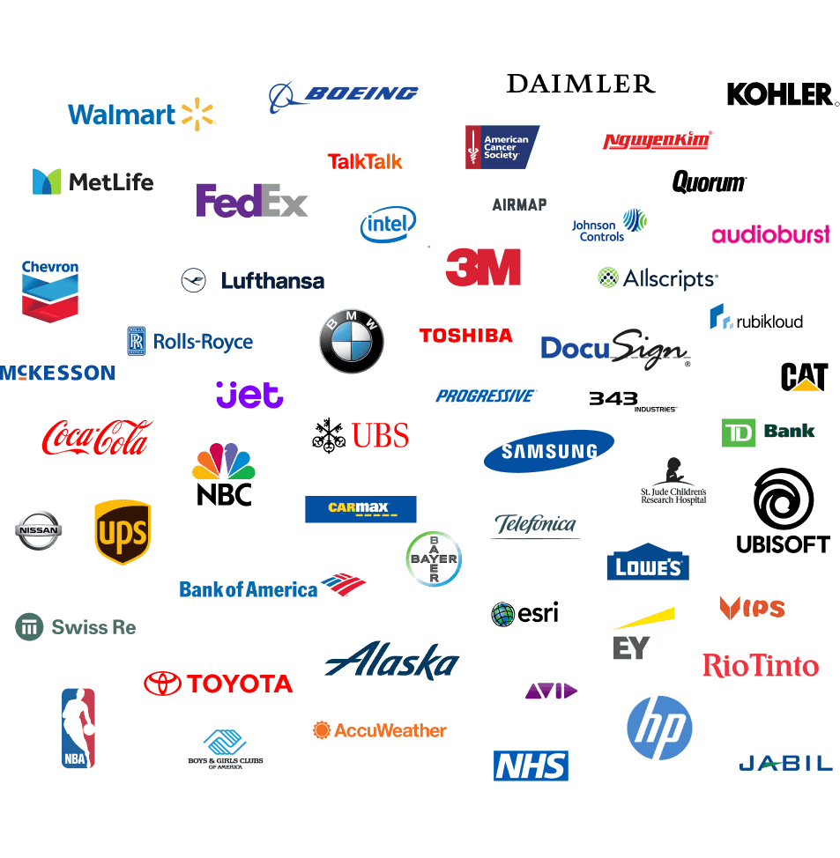

11. Conclusion

* Cloud Computing holds some strong promises
* Highly Available
* Dynamically allocate resources
* Pay only for resources that you use
* Cloud Computing is not yet well understood
* Cloud Computing is new technological development that has the potential to have a great impact on the world
* Reduce operating cost by spending on maintenance and software upgrades and focus more on the businesses

12.References

* <https://www.geeksforgeeks.org>
* <https://en.wikipedia.org/wiki>
* <https://www.javatpoint.com>